Dear Parents and Carers,
We're launching a brand-new Instagram account for Lowercroft Primary! This is something we've been thinking about for a while now and we believe it's the perfect way to share more of the amazing things that happen here every single day.
You know how proud we are of our pupils and all their achievements, both big and small. From fantastic artwork displayed in our corridors to exciting science experiments, sports day triumphs to reading celebrations - there's always something wonderful going on. Our Instagram account will give us the chance to capture these special moments and share them with you in real time.
We want to be completely transparent about how we'll use this platform. Photos of children will feature on our account, but only if you have given your consent for your child to appear in school photographs and social media. We already have your permissions on file from the forms you completed, but if you have any concerns or would like to update your preferences, please don't hesitate to get in touch with the school office.
The account will be managed carefully by our staff team and we'll always ensure that any content we share reflects the positive, nurturing environment we've worked so hard to create at Lowercroft Primary. We see this as another way to celebrate our pupils and keep you connected with school life, especially during those busy weeks when you might not catch us at the gate.
You can search us at lowercroft.primary or scan the QR code below.
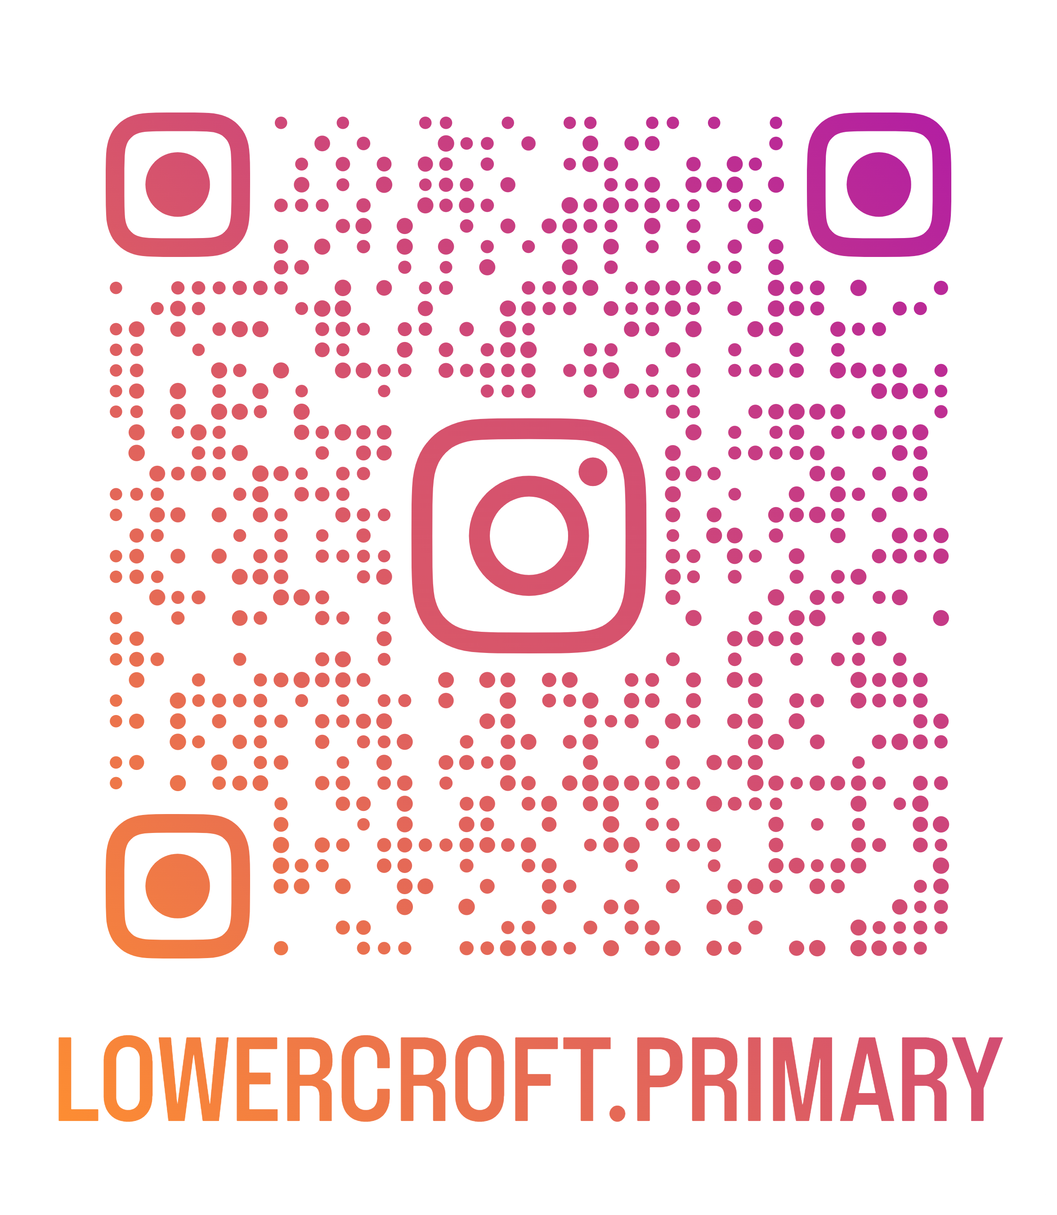
Thank you for your continued support.
Mr Roberts
Deputy Headteacher

