Year R |  | Autumn 1  Getting to Know You | Autumn 2  Let’s Celebrate | Spring 1  Poles and Penguins | Spring 2  Terrific Tales from Around the World | Summer 1  All Creatures Great and Small | Summer 2  Journeys
Class Shared Topic Texts |  | 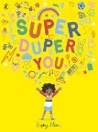  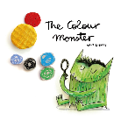  Super, Duper You  The Colour Monster | 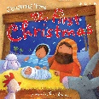  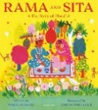  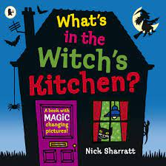  What’s in the Witch’s Kitchen  The First Christmas  Rama and Sita | 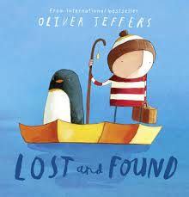  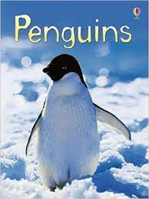  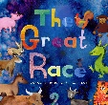  Lost and Found  Penguins  The Great Race | 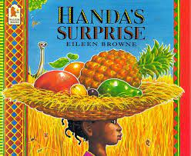  Handa’s Surprise | 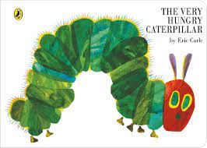  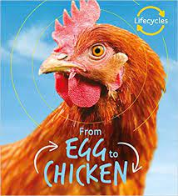  The Hungry Caterpillar  From Egg to Chicken | 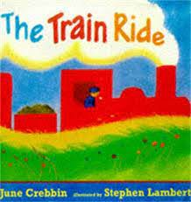  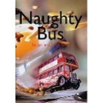  The Naughty Bus  The Train Ride
Literacy Writing Root Text  Literacy Tree Scheme  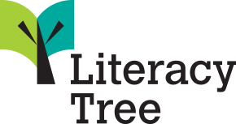 |  | 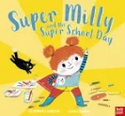  Super Milly and the super school day | 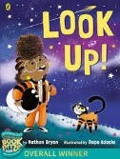  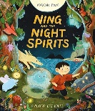  Ning and the Night Spirits  Look Up! | 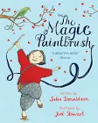  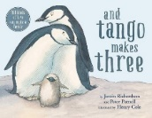  The Magic Paintbrush  And Tango makes three | 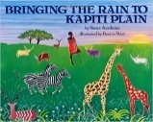  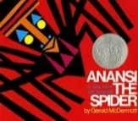  Bringing the Rain to Kapiti Plain  Anasie the spider | 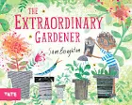  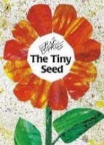  The Tiny Seed  The Extraordianry Gardener | 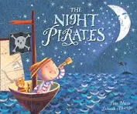  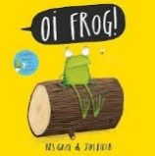  Oi! Frog  Night Pirates
Phonics  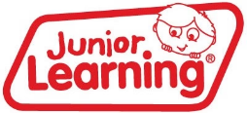 |  | 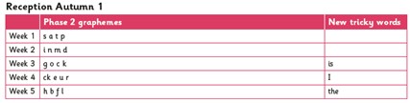  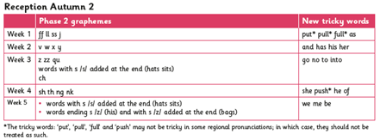 |  | 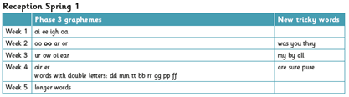  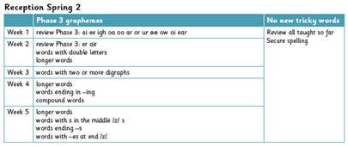 |  | 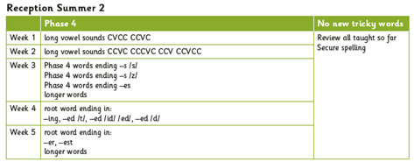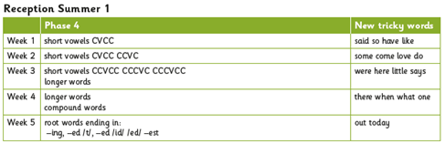
Maths  White Rose Maths Scheme  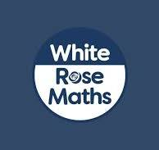 |  | Getting to know you!  Just Like me!  It’s me 1, 2, 3!  Light and Dark |  | Alive in 5!  Growing 6, 7 and 8  Building 9 and 10  Consolidation |  | To 20 and beyond  First, then, now  Find my pattern  On the move!
Maths  NCETM Scheme   |  | Assessments  Counting Song and Rhymes  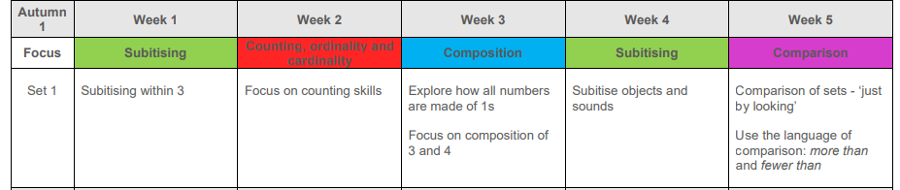  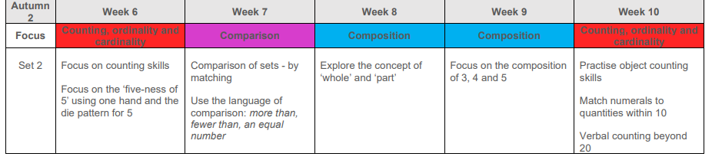 |  | 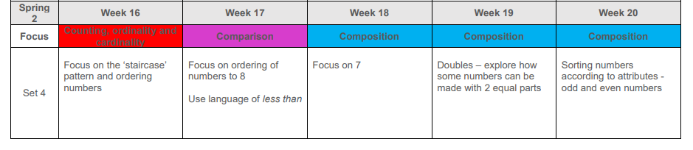  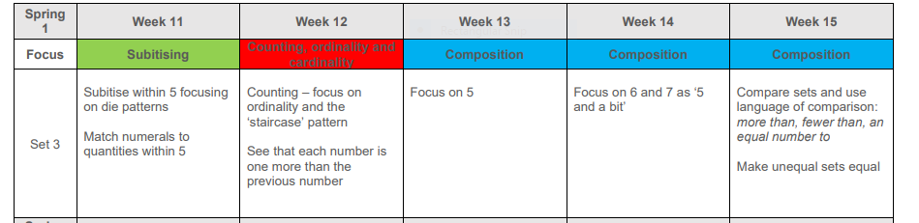 |  | 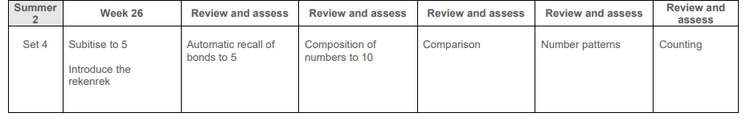  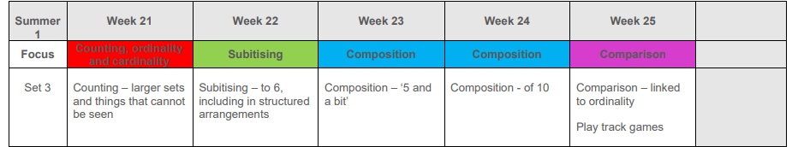
Knowledge of the World | Science | Seasonal Changes - Autumn | Dark and Light | Seasonal Changes- Winter  Experimenting with ice and noticing change |  | Seasonal Changes - Spring Life Cycles and Plants
 | Geography | My Home | Lunar New Year | Polar Lands | Handa’s Village | Our Local Area | Map Making – my journey to school
 | History | All About Me  - My family  - Birthdays | Remembrance Day  Christmas in the Past |  |  | Vehicles in the Past
 | RE  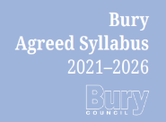 | Why do Christians perform  Nativity Plays at Christmas?  Diwali  Eid  Christmas |  | Why do Christians put a cross in an  Easter garden? |  | Being Special: where do we belong?  What places are special and why?  What times/stories are special and why?
Expressive Arts and Design | Kapow Scheme   | Design Technology | Art and Design | Design Technology | Art and design | Design Technology | Art and Design
 |  | Structures: Junk modelling | Drawing: Marvelous marks | Textiles: Bookmarks | Painting and mixed media: Paint my world | Structures: Boats | Sculpture and 3D: Creation Station
 | Music  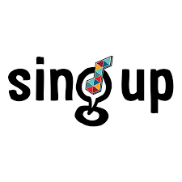 | I’ve got a grumpy face!  Witch, witch | The Sorcerer’s Apprentice  Row, row, row your boat | Bird spotting: Cuckoo polka  Shake my sillies out | Up and down  Five fine bumble bees | Down there under the sea  It’s oh so quiet! | Slap, clap, clap  Bow, bow, bow Belinda!
PE |  | Fundamentals of movement  (Gymnastics) | Fundamentals of Movement (Dance) | Fundamentals of movement  (Gymnastics) | Fundamentals of Movement (Dance) | Games | Games
PHSE |  | Jigsaw Puzzle 1  Being me in my world | Jigsaw Puzzle 2  Celebrating Difference | Jigsaw Puzzle 3  Dreams and Goals | Jigsaw Puzzle 4  Healthy Me | Jigsaw Puzzle 5  Relationships | Jigsaw Puzzle 6  Changing Me
Enrichment  Visits, visitors and parental engagement opportunities. |  | Transition into school  Halloween Disco | Nativity Play  Christmas Stay and Play | Penguin Waddle Fundraiser | Easter Stay and Play  Dentist Visit | Hatching Chicks  Caterpillars in the Classroom | Class Trip  Summer Stay and Play  Walk around the local area

